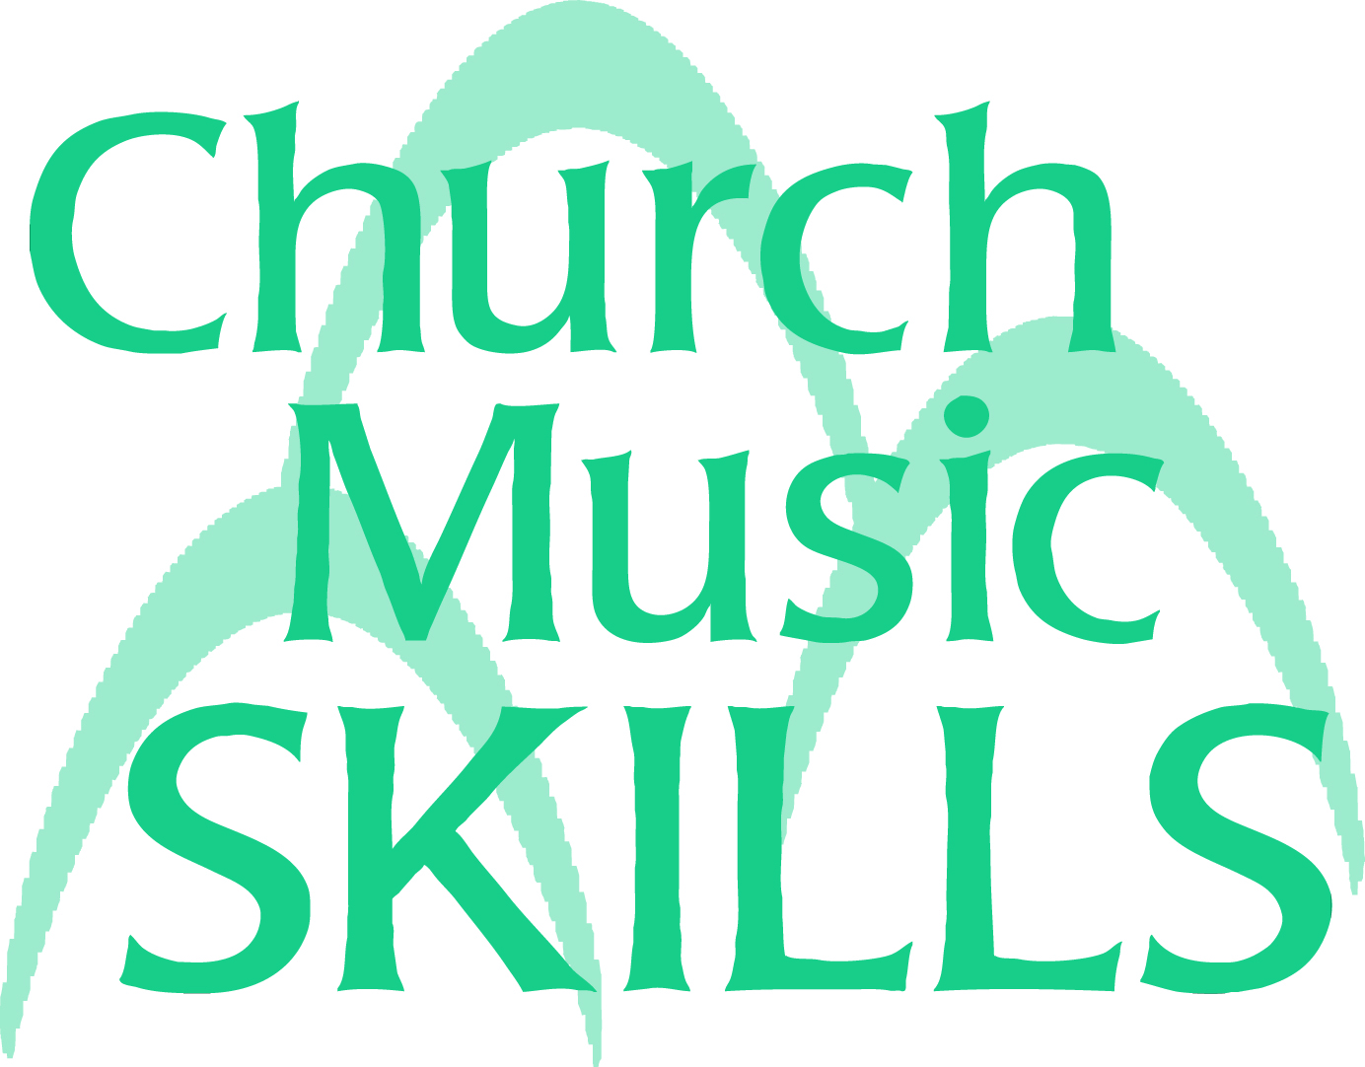

Church Music Skills Feedback Form

We want to hear your views as to how we can improve the Church Music Skills programme. Please complete and submit this form after you have received your tutor feedback on each unit. Ideally, it should be sent as an attachment to skills@rscm.com. Alternatively it can be sent by post to RSCM Skills, 19 The Close, Salisbury SP1 2EB.

Unit number: |  | Unit title:

Answer each question by circling or highlighting the extent to which you agree or disagree with the statement on the marking scale provided:

5 – agree strongly
4 – agree
3 – no particular view
2 – disagree
1 – disagree strongly

(a) The aims of the unit were clear 1 2 3 4 5
(b) The unit was well planned 1 2 3 4 5
(c) The tutor’s feedback was constructive 1 2 3 4 5
(d) The tutor gave clear guidance and advice 1 2 3 4 5
(e) The learning materials were clear, helpful, and instructive 1 2 3 4 5
(f) The unit was enjoyable and stimulating 1 2 3 4 5
(g) The unit was sufficiently demanding 1 2 3 4 5
(h) The unit lived up to my expectations 1 2 3 4 5
(i) The workload was manageable 1 2 3 4 5
(j) The assignments were appropriate 1 2 3 4 5

P.T.O.

Please add further comments on any aspect of the unit below:

