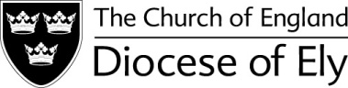 

Ely Festival of Church Music 2019

Ely Cathedral

Saturday 18th May 2019

Rehearsal 1:45pm; Service 5pm

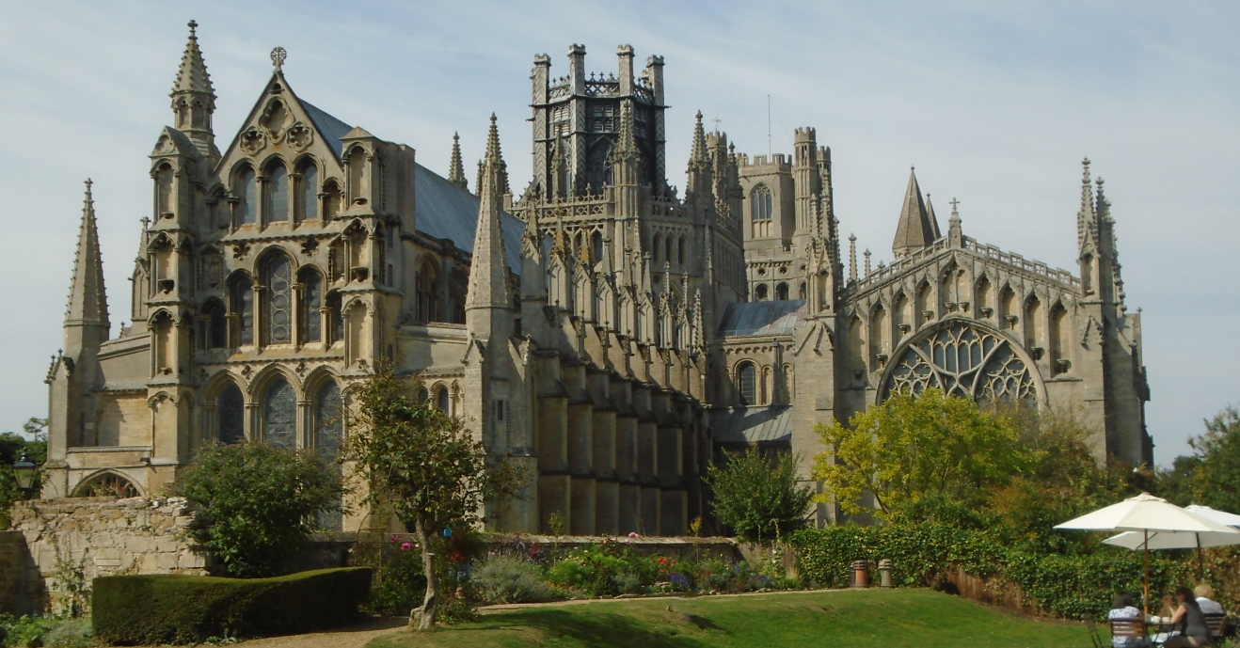

Singers of all ages are warmly invited to join the Festival Choir which will be conducted by Edmund Aldhouse, Assistant Organist at Ely Cathedral. Come and enjoy a great day out in Ely!

Adults £8; Under18s £5 (must be accompanied by an adult)

Price includes one copy of the 2019 RSCM Festival Book *Where Shall Wisdom Be Found* for each singer booked before 15th Jan 2019.

Booking now open –

Visit [www.rscmely.org.uk](http://www.rscmely.org.uk) or email Lydia Cant at [elymembership@talktalk.net](mailto:elymembership@talktalk.net)