Berkshire Area
Secretary: Mary Delaney Tel: 01189403121 Email: mary.delaney@btinternet.com https://www.rscm.org.uk/search-events http://www.rscm-oxford.org.uk/events.htm

Songs for Sighing : Psalms for Lent

A one-day RSCM workshop, using Psalms for the Common Era by Revd Dr Adam Carlill

Saturday 16th March 2019
St Mary Magdalen Church, Tilehurst,
Kentwood Hill, Reading, RG31 6DR

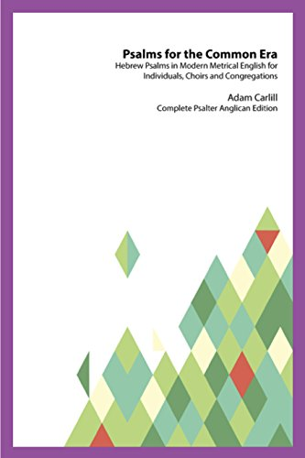

Using Adam Carlill’s newly published book, which you can read about in the December 2018 issue of CMQ (Church Music Quarterly) from the RSCM, we will explore a variety of metrical psalms, set to well-known hymn tunes. Adam will explain more about his work on this project, with particular emphasis on choosing psalms to use during the season of Lent.

We will use books which belong to the Church during the day, but copies of the book will also be available for purchase.
Refreshments, including cake, will be provided at the coffee and tea breaks, but please bring a packed lunch.
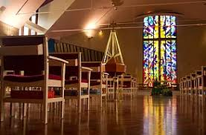

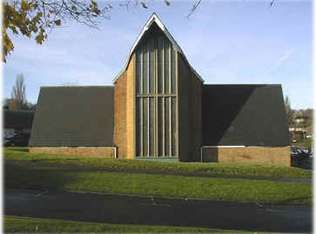
The timetable for the day is likely to be:
10.00 am Welcome and introduction to Psalms for the Common Era
First session: Penitence and Sorrow
11.00 am Coffee
11.30 am Second Session: Illness, Grief and Mortality
12.30 pm Lunch (Please bring a packed lunch)
1.30 pm Third Session: Injustice, Anger and Abuse
2.30 pm Tea
3.00 pm Fourth Session: Meditation, Yearning, Healing and Relief
4.00 pm Conclusion
The cost for the day is only £5, including refreshments, or if you are only able to attend either the morning or afternoon session, the cost is £3. Payment may be sent in advance by post with the booking form below (cheques payable to RSCM Berkshire).
If the booking form is returned by email, payment may be collected on the day, or if you wish to make a direct bank payment please ask for details.
There is limited parking on The Green at the Church (see map below) or in nearby roads, or there is Tilehurst Station car park just across the road. It is also easily accessible by train. Reading Buses no 16 (Sky Blue) service, from near the junction of Friar Street and Station Road, passes the Church (nearest stop is Kentwood Circle), timetable at: https://www.reading-buses.co.uk/services/16?date=2018-09-19&direction=outbound
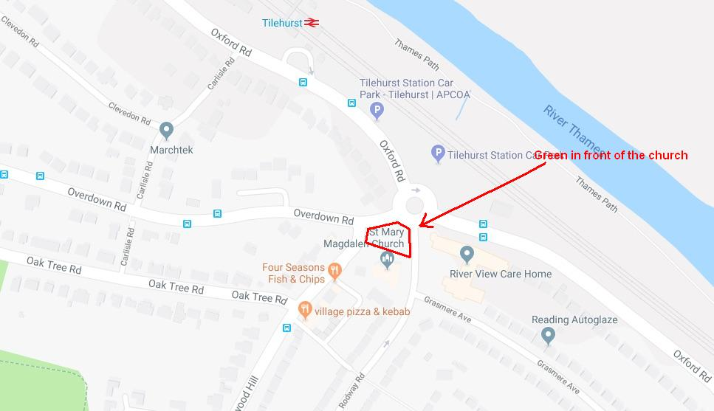
Booking Form for Songs for Sighing: Psalms for Lent 16th March 2019
Please send the following information to Mary Delaney by email as above or by post to
6 East View Close, Wargrave, Berkshire, RG10 8BJ
Contact Name
Contact telephone number
Contact email address
Numbers of people on this booking | All day  Morning only  Afternoon only
Payment enclosed or to be paid

Please let me know if anyone under 18 is included in this group, as they must be accompanied by an adult and we will need a Parental Consent Form to be completed.

