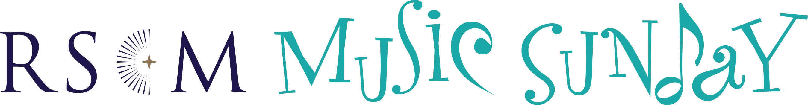

Example Press Release

Dorset based church, xxxxxxxx, is to hold a sponsored hymnathon to raise money for RSCM Music Sunday

[Date]

Churches across the country are being invited to celebrate music in worship by holding a Royal School of Church Music event in June.
The Royal School of Church Music, RSCM, has designated 14 June 2020 as Music Sunday and is encouraging churches to hold special events, concerts, services and collections to celebrate the importance of music in worship.

Dorset based church, xxxxxx, will be holding a hymnathon that will include a fund-raising element, splitting the proceeds between themselves and the worldwide work of the RSCM in supporting church musicians.
[Include your Event details here]
- Date and time, venue
- Details of the activity/event, contact details if necessary
- Goal for numbers participating and money raised, use to which the share of funds will be put locally
- Quotes from individuals such as the music director or RSCM Area Committee Member / Volunteer
- If you held a Music Sunday event last year, give some details – what you did, how much you raised, who was involved]

“I am thrilled, indeed honoured, to see such a wide range of Music Sunday events, as details come in,” says Hugh Morris, RSCM Director
More information about RSCM Music Sunday can be found at www.rscm.org.uk along with details of events registered so far and how to get involved.

Notes for Editors
The Royal School of Church Music (RSCM) is the heart and home of church music.

The RSCM is an educational charity that promotes the best use of music in worship, church life, and the wider community. The RSCM also publishes music and training resources, and organises courses, short workshops, and other activities. RSCM is an international network, with over 8,500 affiliates, members and friends in over 40 countries, supported by over 650 volunteers and a small team of staff based throughout the UK.

For further media enquiries about the RSCM contact:

Angela Hamilton, Marketing Officer, ahamilton@rscm.com / 01722 424839

The Royal School of Church Music
19 The Close, Salisbury, SP1 2EB
Tel: 01722 424848

www.rscm.org.uk

Registered charity no: 312828

