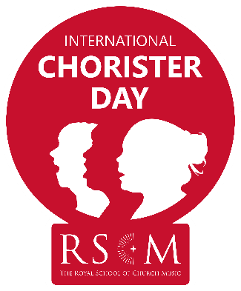
International Chorister Day Event – Venue Name

Your risk assessment should be completed in conjunction with the venue’s risk assessment. In addition, you will need to consider the prevailing guidance around covid at the time of the event.

Risk | Who is at risk  (name all groups and any specific individuals) | Likelihood  (high/low/medium) | Severity  (high/low/medium) | Control measure(s) taken
Health:
Individual singer or member of staff taken ill
Health:
Individual singer or member of staff having an allergic reaction
Safeguarding:
Inappropriate conduct towards under 18 singers by course staff
Safeguarding:
Inappropriate conduct towards under 18 singers by members of the public
Safety:
Unknown people on site
Safety:
Fire
Safety:
Hazards created by building works
Safety:
Slips and trips
Other:
phone at venue

In addition please consider whether you have any individuals attending with specific needs.
Add any relevant telephone numbers

