RSCM FESTIVAL SERVICES

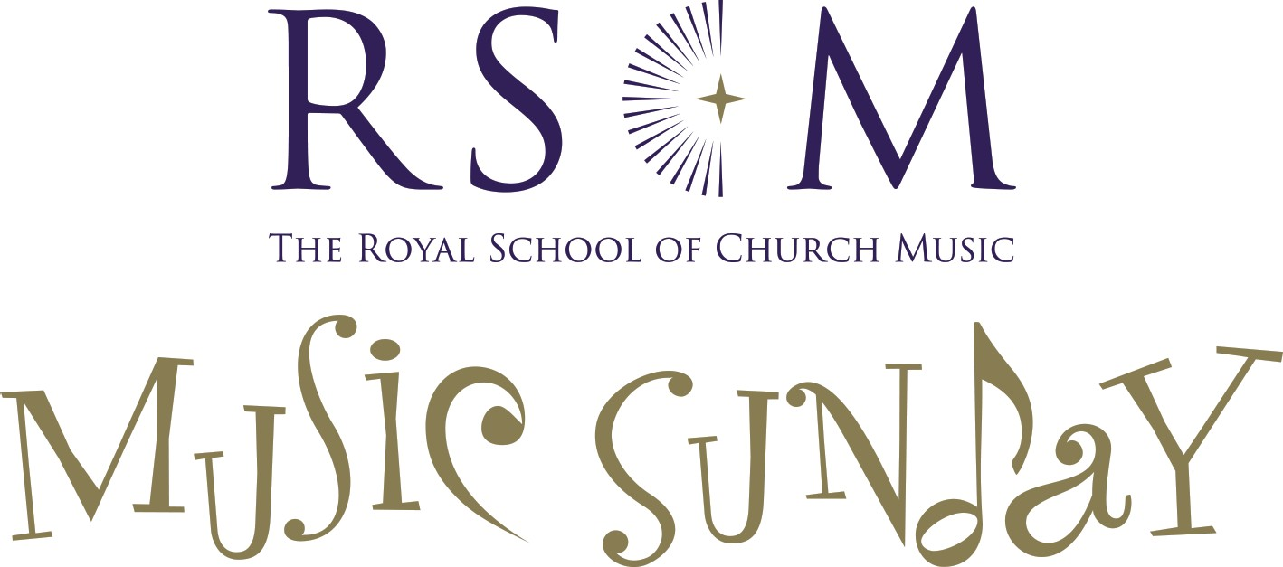

Music Sunday Service

of the Word.

11th June 2023

T H E R O Y A L S C H O O L O F C H U R C H MUSIC

To give thanks is a regular, and often central, element of worship. Often, we give thanks for the gifts God has given each of us, whatever those may be. On Music Sunday, it is good specifically to give thanks for music.

Firstly, we should give thanks for the wonderful, transformative way it can enhance and uplift our worship, be that in shared song, received anthem, or offered on an instrument. As I personally experienced recently at a service where the music moved me to tears, it has the unique power to bring words to a deeper level of meaning than they can on their own convey.

Secondly, we should give thanks for all those who have been bestowed with musical gifts. This specifically includes when they are used in the service of the church, whether as experienced and skilled professional or as someone at the very beginning of a journey into musical participation in worship. The time and talent invested week by week, month by month and in many cases decade by decade is often offered in quiet, devoted service – rightly so in that it is the music and the worship which take precedence over the performer. But to take a moment to say a public ‘thank you’ for that devotion is a good and valuable thing to do, lest it be taken for granted.

Lastly, we should give thanks for the power of music in helping the church to open her doors wide and welcome (new) people in. Be that in services, concerts, or other events, it provides an opportunity to connect with the communities in which each of our churches sit. To feel welcome stepping over the threshold of a church, for whatever reason, is to enable a step towards encountering God, and the wonders of the Christian faith.

For all these and more, then, we offer to God our humble and heartfelt thanks indeed.

Hugh Morris
Director, RSCM.

The Gathering
Opening Hymn (A&M 589):

- Angel-voices ever singing
round Thy throne of light,
angel-harps for ever ringing,
rest not day nor night;
thousands only live to bless Thee
and confess thee
Lord of might.

- Thou who art beyond the farthest
mortal eye can scan,
can it be that Thou regardest
songs of sinful man?
Can we know that Thou art near us,
and wilt hear us?
Yea, we can.
- Yea, we know that thou rejoicest
o'er each work of Thine;
Thou didst ears and hands and voices
for Thy praise design;
craftsman's art and music's measure
for Thy pleasure
all combine.

- In thy house, great God, we offer
of Thine own to Thee;
and for Thine acceptance proffer
all unworthily
hearts and minds and hands and voices
in our choicest
psalmody.
- Honour, glory, might, and merit
Thine shall ever be,
Father, Son, and Holy Spirit,
blessèd Trinity.
Of the best that Thou hast given
earth and heaven
render Thee.
Tune: Angel Voices
Words: F. Pott; Music: E. G. Monk.

In the name of the Father,
and of the Son,
and of the Holy Spirit.
All Amen.

Grace, mercy and peace
from God our Father
and the Lord Jesus Christ
be with you
All and also with you.

The congregation is welcomed and the service introduced.

Prayer of Preparation

All Holy God,
to whom worship is due both day and night,
accept our humble offerings of praise,
so that our hearts may feel your fatherly love,
our souls be inspired by your Holy Spirit
and our minds be filled with the knowledge of Christ,
for you reign, in earth and sky and sea,
Trinity in Unity.
Amen.

Prayers of Penitence

Let us confess our sins in penitence and faith,
firmly resolved to keep God’s commandments
and to live in love and peace with all.

Silence is kept for a short time.

All Most merciful God,
Father of our Lord Jesus Christ,
we confess that we have sinned
in thought, word and deed.
We have not loved you with our whole heart.
We have not loved our neighbours as ourselves.
In your mercy
forgive what we have been,
help us to amend what we are,
and direct what we shall be;
that we may do justly,
love mercy,
and walk humbly with you, our God.
Amen.

Almighty God,
who forgives all who truly repent,
have mercy upon you (us),
pardon and deliver you from all your (our) sins,
confirm and strengthen you (us) in all goodness,
and keep you (us) in life eternal;
through Jesus Christ our Lord.
All Amen.

Gloria in Excelsis
The Gloria, an ancient hymn of praise, may be sung or said.

All Glory to God in the highest,
and peace to his people on earth.
Lord God, heavenly King,
almighty God and Father,
we worship you, we give you thanks,
we praise you for your glory.
Lord Jesus Christ, only Son of the Father,
Lord God, Lamb of God,
you take away the sin of the world:
have mercy on us;
you are seated at the right hand of the Father:
receive our prayer.
For you alone are the Holy One,
you alone are the Lord,
you alone are the Most High, Jesus Christ,
with the Holy Spirit,
in the glory of God the Father.
Amen.

The Collect for Music Sunday

God of majesty,
whom saints and angels delight to worship in heaven:
be with your servants who make music with your people,
that, with joy, we on earth may glimpse your beauty;
and bring us to the fulfilment of that hope of perfection,
which will be ours as we stand before your unveiled glory,
through Jesus Christ our Lord.
All Amen.

The Liturgy of the Word
First Reading: Revelation 5.6-end

Then I saw between the throne and the four living creatures and among the elders a Lamb standing as if it had been slaughtered, having seven horns and seven eyes, which are the seven spirits of God sent out into all the earth. He went and took the scroll from the right hand of the one who was seated on the throne. When he had taken the scroll, the four living creatures and the twenty-four elders fell before the Lamb, each holding a harp and golden bowls full of incense, which are the prayers of the saints.
They sing a new song:
‘You are worthy to take the scroll and to open its seals,
for you were slaughtered and by your blood you ransomed for God saints from every tribe and language and people and nation;
you have made them to be a kingdom and priests serving our God,
and they will reign on earth.’

Then I looked, and I heard the voice of many angels surrounding the throne and the living creatures and the elders; they numbered myriads of myriads and thousands of thousands, singing with full voice,
‘Worthy is the Lamb that was slaughtered
to receive power and wealth and wisdom and might
and honour and glory and blessing!’

Then I heard every creature in heaven and on earth and under the earth and in the sea, and all that is in them, singing,
‘To the one seated on the throne and to the Lamb
be blessing and honour and glory and might
for ever and ever!’
And the four living creatures said, ‘Amen!’ And the elders fell down and worshipped

Gradual Hymn:

- When in our music God is glorified,
and adoration leaves no room for pride,
it is as though the whole creation cried,
Alleluia!

- How often, making music, we have found
a new dimension in the world of sound,
as worship moved us to a more profound
Alleluia!

- So has the Church, in liturgy and song,
in faith and love, through centuries of wrong,
borne witness to the truth in ev'ry tongue.
Alleluia!

- And did not Jesus sing a psalm that night
when utmost evil strove against the Light?
Then let us sing, for whom he won the fight,
Alleluia!

- Let ev'ry instrument be tuned for praise!
Let all rejoice who have a voice to raise!
And may God give us faith to sing always
Alleluia!
Tune: Engelberg; Music: C V Stanford (1852-1924)
Words: F Pratt Green (1903-2000)

The Gospel: Luke 7.31-35

Jesus said, ‘To what then will I compare the people of this generation, and what are they like? They are like children sitting in the market-place and calling to one another,
“We played the flute for you, and you did not dance;
we wailed, and you did not weep.”
For John the Baptist has come eating no bread and drinking no wine, and you say, “He has a demon”; the Son of Man has come eating and drinking, and you say, “Look, a glutton and a drunkard, a friend of tax-collectors and sinners!”
Nevertheless, wisdom is vindicated by all her children.’

The Sermon (this may take the form of an interview or conversation with others involved in shaping the Church’s music in worship).

The Creed: this (or another authorised version) may be said or sung.

Let us declare our faith in God, Father, Son and Holy Spirit.

All We believe in God the Father,
God almighty, by whose plan
earth and heaven sprang to being,
all created things began.
We believe in Christ the Saviour,
Son of God in human frame,
virgin-born, the child of Mary
upon whom the Spirit came.

Christ, who on the cross forsaken,
like a lamb to slaughter led,
suffered under Pontius Pilate,
he descended to the dead.
We believe in Jesus risen,
heaven’s king to rule and reign,
to the Father’s side ascended
till as judge he comes again.

We believe in God the Spirit;
in one Church, below, above:
saints of God in one communion,
one in holiness and love.
So by faith, our sins forgiven,
Christ our Saviour, Lord and friend,
we shall rise with him in glory
to the life that knows no end.

Words: Common Worship. Tune: Abbots Leigh

The Prayers of Intercession
The congregation kneels or sits.
This response and conclusion, or an alternative, is used:
Lord, in your mercy,
All hear our prayer.

Merciful Father,
All Accept these prayers for the sake of your Son,
our Saviour Jesus Christ. Amen.

Stand.

The Peace

You shall go out in joy and be led back in peace;
the mountains and the hills before you shall
burst into song, and all the trees of the field
shall clap their hands. Isaiah 55.12

The peace of the Lord be always with you
All and also with you.

Let us offer one another a sign of peace.

All are invited to exchange a sign of peace.
Hymn (A&M 777)
during the singing of the hymn, a collection may be taken, donations to be shared between the Royal School of Church Music and the local charity.

- Sing of the Lord’s goodness, Father of all wisdom,
come to him and bless his name.
Mercy he has shown us, his love is for ever,
faithful to the end of days.

Come, then, all you nations,
sing of your Lord’s goodness,
melodies of praise and thanks to God.
Ring out the Lord’s glory,
praise him with your music,
worship him and bless his name.

- Power he has wielded, honour is his garment,
risen from the snares of death.
His word he has spoken, one bread he has broken,
new life he now gives to all:
Come, then, all…

- Courage in our darkness, comfort in our sorrow,
Spirit of our God most high;
solace for the weary, pardon for the sinner,
splendour of the living God:
Come, then, all…

- Praise him with your singing, praise him with the
/trumpet,
Praise God with the lute and harp;
Praise him with the cymbals, praise him with your dancing,
Praise God till the end of days:
Come, then, all…
Words: Ernest Sands
Tune: E. Sands and C. Walker; arr. P. Inwood

Sending out
Closing prayers

Great Father of glory,
we praise you for your eternal light,
illuminating the splendour of your creation
and brightening the gloom of our troubled world.
May your unchanging love inspire your Church
in all goodness and grace,
so that all your people may dwell in justice, harmony and peace,
for you reign with Christ and the Spirit,
high soaring in heaven, and deep in our hearts.
All Amen.

Let us go forth into the world,
singing psalms and hymns and spiritual songs among ourselves,
and making melody to the Lord in our hearts,
and may the blessing of the Holy Trinity,
the Father, the Son and the Holy Spirit,
be with you (us) all, in your (our) hearts and voices,
now and always.
All Amen.

adapted from The Chorister’s Pocket Prayer Book
rscm 2021
Let us go in peace to love and serve the Lord.
All In the name of Christ. Amen.

As the ministers depart, the following music is offered to listen to, as the worship concludes.

